Contributor: Mariana Westphalen Von Hartenthal

**Berni, Antonio**

Born: Rosario, 1905 - Died: Buenos Aires, 1981

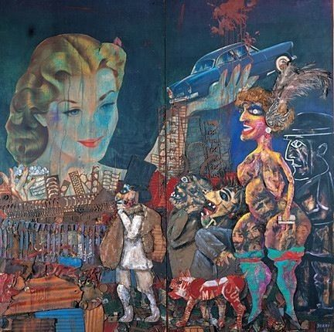

Antonio Berni, *La gran tentación* (The Big Temptation) or *La gran ilusión* (The Great Illusion), 1962

Mixed media

245 x 251.5 cm

MALBA - Museo de Arte Latinoamericano de Buenos Aires (<http://www.malba.org.ar/web/home.php>)

Antonio Berni is a central figure in twentieth-century Argentinean art with a long and diverse production. He experimented with a wide variety of techniques, from oil painting to collages and large sculptures. Berni frequently incorporated trash and other industrialized, humble materials, into his pieces. The artist’s complex prints combined traditional printmaking techniques and collage with found materials, securing him the Grand Prize for Drawing and Printmaking at the 1962 Venice Biennale. Berni usually address the inequality and injustices he witnessed in Argentina, a result of the rapid growth in industrialization and consumerism. His works, predominantly figurative, have a cluttered, grimy aspect. At the beginning of his career in the 1920s and early 1930s, Berni was influenced by the surrealists, with whom he became familiar on a study trip to Europe. During the 1930s, the artist created monumental paintings; he also delineated the movement *Nuevo Realismo* (New Realism), an attempt to put art closer to a broader audience. In the 1950s, the artist started his famous series portraying the lives of Juanito Laguna and Ramona Montiel, two characters he depicted in print and sculptures. In the 1960s, he developed the series of *Montruos* (Monsters) of sculptures made with scrap material.

In 1933, Berni worked with **David Alfaro Siqueiros**, Lino Spilimbergo, Juan Castagnino, and Enrique Lázaro on the mural *Ejercício plástico* (Plastic Exercise). He later criticized this experience because he understood that mural painting could only exist in Argentina with the collaboration of the bourgeoisie. The large canvas paintings from the period, such as *Manifestación* (Demonstration, 1934) -- which depicts working class subjects oppressed and alienated by capitalism -- are a way to adapt the Mexican muralist practice to the Argentine context.

The character Juanito Laguna is a slum boy. He is shown in a variety of situations that range from everyday activities such as helping his mother with house chores or on his way to the city, to scenes in a fantastic world inhabited by spaceships. Ramona Montiel is also poor, although not as destitute as Juanito. Initially an innocent girl, she moves to the big city and becomes a prostitute. She is shown performing in cabarets, traveling the world, and in the company of men from all walks of life. Advertising images of luxury goods frequently appear in both series, as a criticism to the consumerism that make people like Juanito and Ramona almost as disposable as the waste among which they live. A similar commentary on capitalism appears in the sculptures of the series *Monstruos cósmicos* (Cosmic Monsters) and *Los monstruos del infierno se disputan a Ramona* (The Monsters of Hell Fight over Ramona), in which debris and found objects are used as raw material for pieces such as *La sordidez* (Sordidness, ca. 1964), and *Voracidad* (Voracity, 1965).

**Further reading:**

Ramírez, M. C., Olea, H., and Pacheco, M. E., eds. (2013) *Antonio Berni: Juanito and Ramona*, Museum of Fine Arts, Houston, and Museo de Arte Latinoamericano de Buenos Aires.

Giunta, A. (2004) “Rewriting Modernism: Jorge Romero Brest and the Legitimation of Argentine Art.” *Listen, Here, Now!: Argentine Art of the 1960s: Writings of the Avant-Garde*, Katzenstein, I. (ed.), New York: The Museum of Modern Art, 78-85.

Anreus, A. (2008) “Adapting to Argentinean Reality: The New Realism of Antonio Berni,” in *The Social and the Real: Political Art of the 1930s in the Western Hemisphere*, Anreus, A., Linden, D. L., and Weiberg, J. (eds.), University Park: Pennsylvania State University Press, pp. 97-112.

Barnitz, J. (2001) *Twentieth-Century Art of Latin America*, Austin: The University of Texas Press.

Pacheco, M. (1999) *Berni: Escritos y papeles*, Buenos Aires: Tema Grupo Editorial.

**List of Works:**

*La siesta y su sueño (The Siesta and its Dream*), 1932. Oil on canvas. 52,5 x 69 cm. Museo de Arte Latinoamercano de Buenos Aires.

*Manifestación (Demonstration*), 1934. Tempera on burlap. 180 x 249 cm. Museo de Arte Latinoamercano de Buenos Aires.

*Juanito va a la ciudad* (*Juanito Goes to the City*), 1963. Wood, paint, industrial trash, cardboard, scrap metal, and fabric assemblage on board. 327,5 x 200,5 x 38 cm. Museum of Fine Arts, Houston.

*La sordidez (de la serie “Monstruos cósmicos”) (Sordidness, from the series “Cosmic Monsters”)*, ca. 1964*.* Wood, steel, iron, aluminum, cardboard, plastic, roots, nails, and enamel.

129 x 120 x 445,5 cm with platform. Museum of Fine Arts, Houston.

*Ramona y el viejo (Ramona and the Old Man*), 1962. Xylo-collage-relief on paper. 175 x 70 cm. Museo de Arte Latinoamercano de Buenos Aires.